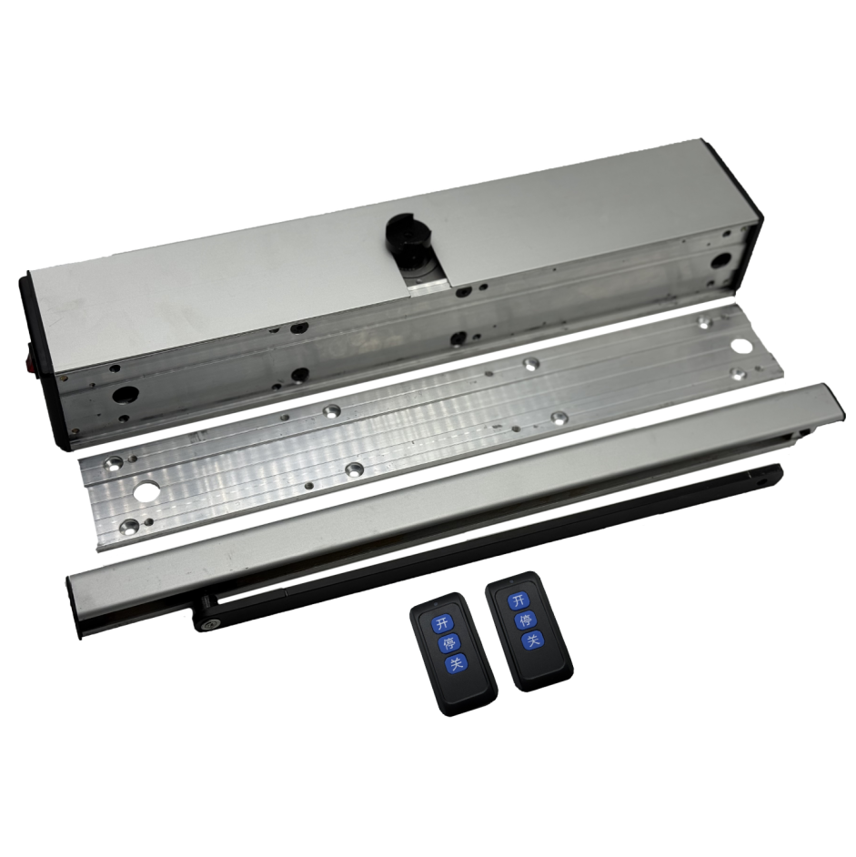
Specification of top-mounted swing door operator
Item | Parameter | Remark
Working voltage | 220VAC±15% 50Hz
Motor operating voltage | 24VDC
Power of motor | 60W
Rated output torque | 34Nm
Angular speed | 40.75°/s
Maximum opening Angle | ±90°
Maximum length of door leaf | 2m (single door)
Maximum weight of door leaf | 200Kg
Thermal protection on motor winding | F Class 155℃
Operating frequency | Continuous running below 70℃
Operating ambient temperature | -25-70℃
Working environment | Indoor or sheltered outdoor environments
Running noise | ≤60dB
Temperature rise | ≤15℃
Weight of equipment packaging | 5.3kg
Body size (length * width * thickness) | 330*85*84.4mm
Packing size | 530*180*110mm

